Motion, Forces, and Energy

Motion, forces, and energy are three closely related ideas. Each helps explain how and why things happen the way they do in our physical world.

Law of Conservation of Energy
Energy can turn from one type of energy to another. We call this an energy transformation. During energy transformations, energy is often released as light, heat, or sound. Although energy can change into different forms, it is never lost. This is known as the law or principle of conservation of energy.

Besides the types of energy we have already discussed, energy can also be classified as kinetic energy or potential energy. Kinetic energy is the energy an object has due to its motion. Potential energy is stored energy. All energy is either potential or kinetic. Energy can be classified by its source (mechanical, radiant, sound, chemical, heat, electrical, nuclear) and its type (potential or kinetic).

When an object moves, it has kinetic energy. Two things affect the amount of kinetic energy in a moving object: speed and mass. Speed is important because the faster an object moves, the greater its kinetic energy.

We get most of our energy on Earth from the sun.

Energy is the ability to do work or cause change. Light from the sun is one form of energy. Sunlight is a product of a nuclear fusion reaction inside the sun. During fusion, hydrogen atoms combine to form helium atoms. This process releases a tremendous amount of energy. Some of this energy reaches Earth in the form we call sunlight. When the sunlight reaches Earth, it enters ecosystems.
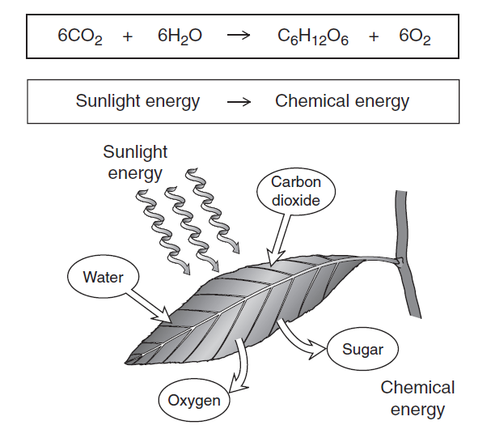

Plants use energy from sunlight to change carbon dioxide and water into sugar during photosynthesis. So some of the energy in sunlight is converted to the energy in the bonds of the sugar molecules. This is one way light energy is converted to chemical energy. Chemical energy is held in the bonds between the atoms in molecules. When molecules undergo a chemical change, they may release the energy held in their chemical bonds in another form, such as heat, light, or electricity.

Other Common Energy Transformations
Many energy transformations happen in a in a CD player. The CD player needs energy to play music. If the CD player is plugged into the wall the electricity comes out. Plugging it in allows electrical energy to flow from the outlet to the CD player. A flow of electrons (current) through a conductor produces electrical energy.

What causes electrons to flow in the conductors inside the wall outlet? Power lines carry electricity to the electrical outlet in the wall. Electrical power can be generated in several ways. For example, coal or natural gas may be burned to generate electricity. The energy transformations used in generating electrical power from burning coal are shown below.
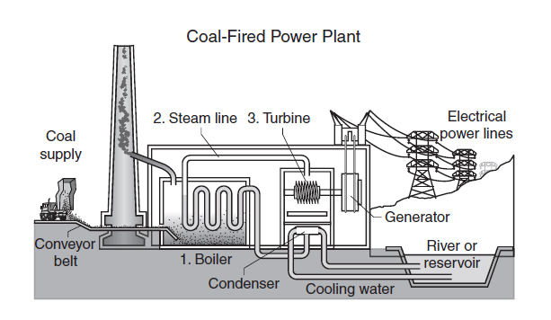
The water flowing through a dam in a river can be used to move turbines to generate electricity. Wind generators use the energy of moving wind to operate a generator that produces electricity. Nuclear power plants convert atomic energy into heat. This heat boils water to form steam and then follows the same energy transformations as in a coal power plant. The electrical energy generated in all these ways can then be sent through power lines to houses and other buildings.
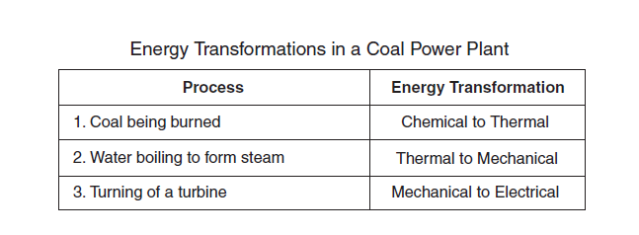
You are still using energy if you put batteries in your CD player. Batteries store chemical compounds that react when they are used to power the CD player. This produces a flow of electrons in the circuits of the CD player. Chemical energy in the batteries is converted to electrical energy in the CD player. There are even more energy transformations that occur in the CD player to produce the actual music that you hear.

Other Energy Transformations in a CD Player

The CD player uses electricity to spin the CD. The spinning CD has mechanical energy. Mechanical energy is the energy in an object due to its position or motion. So another energy transformation in the CD player is electrical energy to mechanical energy.
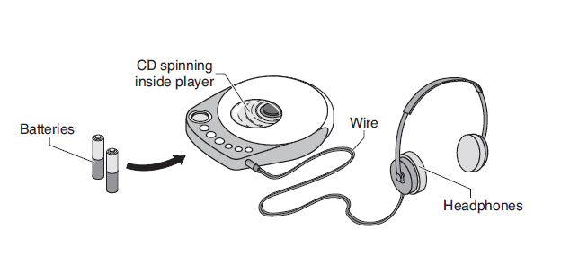
Sound is Energy
The CD player produces music from the CD. The CD player uses a laser to convert the digital information on the CD’s surface into electrical energy. This energy is carried to the headphones. There is a material inside the headphones that vibrates in response to the electrical energy. Sound consists of mechanical energy waves created by vibrating objects. Sound must travel through something such as air, water, or a solid.

